**Name: Abinash Satapathy**

**Reg. No: 16BCE0081**

**Slot: C1**

**Subject: Data Visualisation (CSE3020)**

**Review 2**

library(ggplot2)

library(readr)

library(dplyr)

library(RColorBrewer)

library(gganimate)

India <- ClimateCountry %>% filter(Country=="India")

India$dt <-as.Date(India$dt)

India$Year <- format(India$dt,"%Y")

India$Month <- format(India$dt,"%m")

India %>% filter(!is.na(AverageTemperature)) %>%

filter(Year > 1850) %>%

group_by(Year) %>% mutate(no_of_cases= length(Year)) %>%

group_by(Month) %>%

mutate(avg_tempMonth= mean(AverageTemperature)) %>%

filter(no_of_cases==12) %>%

ggplot(aes(Month,AverageTemperature,group=Year,cumulative = TRUE,alpha=Year,label=Year,frame=Year)) +

geom_line(color="grey20") +

geom_line(aes(Month,avg_tempMonth,frame= 2013 + as.numeric(Month) , group=1),size= 2.3,color= "dodgerblue3") +

#geom_text(aes(x=06,y=20,cumulative=FALSE),size=30,color="grey20") +

theme_minimal(base_family = "Ubuntu Condensed")+

scale_x_discrete(labels=c("Jan","Feb","Mar","Apr","May","Jun","Jul","Aug","Sept","Oct","Nov","Dec"))+

theme(legend.position = "none",axis.title = element_blank(),

panel.grid.major.x = element_blank(),

panel.grid.minor.x = element_blank(),

panel.grid.minor.y = element_blank(),

plot.background = element_rect(fill = "#EFF2F4"),

axis.text = element_text(size = 12),

plot.title = element_text(size=18,face = "bold")) +

ggtitle("Average Temperature in India",subtitle = "1850 to 2013") +

labs(caption= "Vamsi Krishna \t Source: Kaggle")

p<-

India %>% filter(!is.na(AverageTemperature)) %>%

filter(Year > 1850) %>%

group_by(Year) %>% mutate(no_of_cases= length(Year)) %>%

group_by(Month) %>%

mutate(avg_tempMonth= mean(AverageTemperature)) %>%

filter(no_of_cases==12) %>%

ggplot(aes(Month,AverageTemperature,group=Year,cumulative = TRUE,alpha=Year,label=Year,frame=Year)) +

geom_line(color="grey20") +

geom_line(aes(Month,avg_tempMonth,frame= 2013 + as.numeric(Month) , group=1),size= 2.3,color= "dodgerblue3") +

geom_text(aes(x=06,y=20,cumulative=FALSE),size=30,color="grey20") +

theme_minimal(base_family = "Ubuntu Condensed")+

scale_x_discrete(labels=c("Jan","Feb","Mar","Apr","May","Jun","Jul","Aug","Sept","Oct","Nov","Dec"))+

theme(legend.position = "none",axis.title = element_blank(),

panel.grid.major.x = element_blank(),

panel.grid.minor.x = element_blank(),

panel.grid.minor.y = element_blank(),

plot.background = element_rect(fill = "#EFF2F4"),

axis.text = element_text(size = 12),

plot.title = element_text(size=18,face = "bold")) +

ggtitle("Average Temperature in India",subtitle = "1850 to 2013") +

labs(caption= "Vamsi Krishna \t Source: Kaggle")

gganimate(p,"Output.gif",ani.width=810, ani.height=520, interval=0.1,title_frame = F)

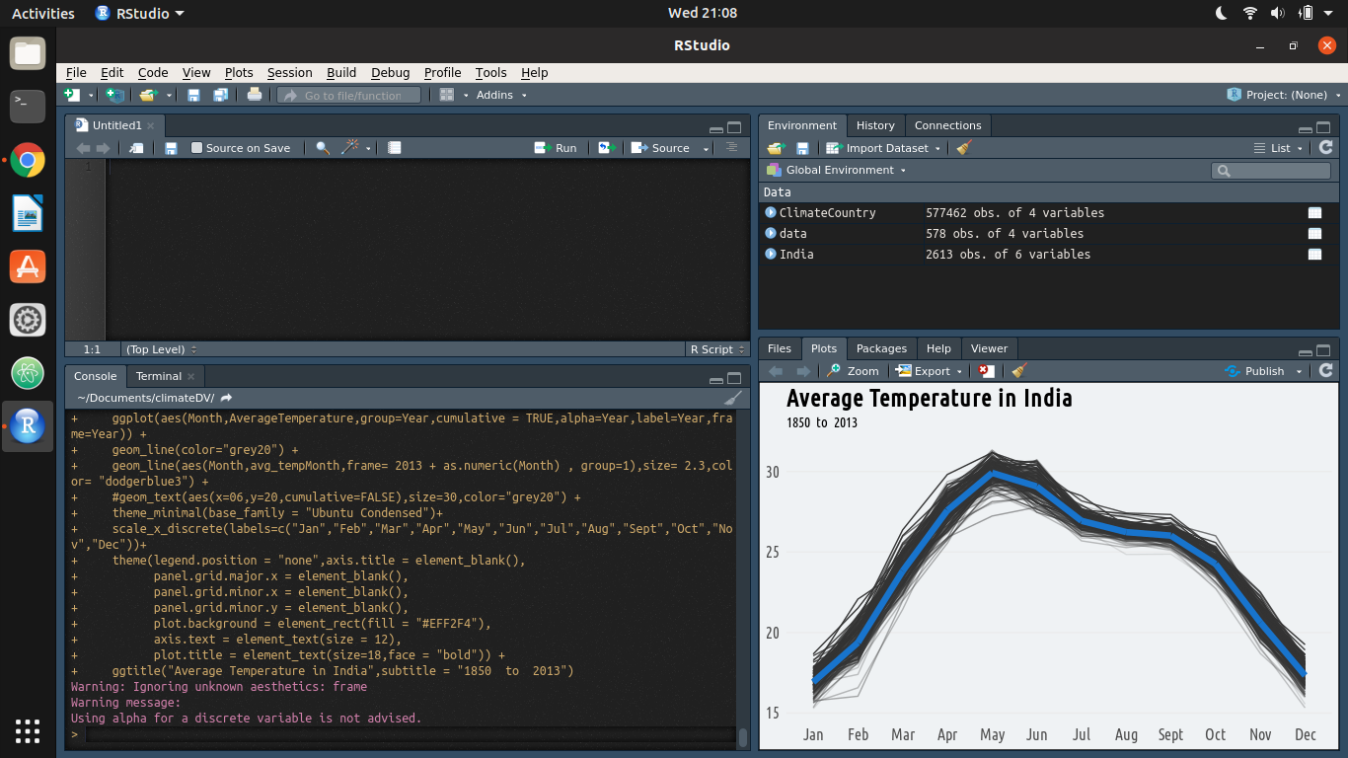



It is a gif.

library(sp)

library(maps)

library(raster)

library(gstat)

library(geoR)

library(maptools)

library(GISTools)

library(animation)

#library(readr)

glt$O1 <- substr(glt$Longitude, nchar(glt$Longitude), nchar(glt$Longitude))

glt$O2 <- substr(glt$Latitude, nchar(glt$Latitude), nchar(glt$Latitude))

glt$Longitude <- ifelse(glt$O1 == "W",

-as.numeric(substr(glt$Longitude, 1, nchar(glt$Longitude)-1)),

as.numeric(substr(glt$Longitude, 1, nchar(glt$Longitude)-1)))

glt$Latitude <- ifelse(glt$O2 == "S",

-as.numeric(substr(glt$Latitude, 1, nchar(glt$Latitude)-1)),

as.numeric(substr(glt$Latitude, 1, nchar(glt$Latitude)-1)))

glt$Year <- substr(glt$dt, 1, 4)

glt.continent = data.frame(

Country = c(

"Algeria","Angola","Benin","Botswana","Burkina Faso","Burundi","Cameroon","Central African Republic","Chad","Congo","Congo (Democratic Republic Of The)","Côte D'Ivoire","Djibouti","Egypt","Equatorial Guinea","Eritrea","Ethiopia","Gabon","Gambia","Ghana","Guinea","Guinea Bissau","Kenya","Lesotho","Liberia","Libya","Madagascar","Malawi","Mali","Mauritania","Mauritius","Morocco","Mozambique","Namibia","Niger","Nigeria","Reunion","Rwanda","Senegal","Sierra Leone","Somalia","South Africa","Sudan","Swaziland","Tanzania","Togo","Tunisia","Uganda","Zambia","Zimbabwe","Afghanistan","Bahrain","Bangladesh","Burma","Cambodia","China","Hong Kong","India","Indonesia","Iran","Iraq","Israel","Japan","Jordan","Kazakhstan","Laos","Lebanon","Malaysia","Mongolia","Nepal","Oman","Pakistan","Philippines","Qatar","Russia","Saudi Arabia","Singapore","South Korea","Sri Lanka","Syria","Taiwan","Tajikistan","Thailand","Turkey","Turkmenistan","United Arab Emirates","Uzbekistan","Vietnam","Yemen","Albania","Armenia","Austria","Azerbaijan","Belarus","Belgium","Bosnia And Herzegovina","Bulgaria","Croatia","Cyprus","Czech Republic","Denmark","Estonia","Finland","France","Georgia","Germany","Greece","Hungary","Iceland","Ireland","Italy","Latvia","Lithuania","Macedonia","Moldova","Montenegro","Netherlands","Norway","Poland","Portugal","Romania","Serbia","Slovakia","Slovenia","Spain","Sweden","Switzerland","Ukraine",

#"United Kingdom",

"UK",

"Bahamas","Canada","Costa Rica","Cuba","Dominican Republic","El Salvador","Guatemala","Haiti","Honduras","Jamaica","Mexico","Nicaragua","Panama","Puerto Rico",

#"United States",

"USA",

"Australia","New Zealand","Papua New Guinea","Argentina","Bolivia","Brazil","Chile","Colombia","Ecuador","Guyana","Paraguay","Peru","Suriname","Uruguay","Venezuela"

),

Continent = c(

"Africa","Africa","Africa","Africa","Africa","Africa","Africa","Africa","Africa","Africa","Africa","Africa","Africa","Africa","Africa","Africa","Africa","Africa","Africa","Africa","Africa","Africa","Africa","Africa","Africa","Africa","Africa","Africa","Africa","Africa","Africa","Africa","Africa","Africa","Africa","Africa","Africa","Africa","Africa","Africa","Africa","Africa","Africa","Africa","Africa","Africa","Africa","Africa","Africa","Africa","Asia","Asia","Asia","Asia","Asia","Asia","Asia","Asia","Asia","Asia","Asia","Asia","Asia","Asia","Asia","Asia","Asia","Asia","Asia","Asia","Asia","Asia","Asia","Asia","Asia","Asia","Asia","Asia","Asia","Asia","Asia","Asia","Asia","Asia","Asia","Asia","Asia","Asia","Asia","Europe","Europe","Europe","Europe","Europe","Europe","Europe","Europe","Europe","Europe","Europe","Europe","Europe","Europe","Europe","Europe","Europe","Europe","Europe","Europe","Europe","Europe","Europe","Europe","Europe","Europe","Europe","Europe","Europe","Europe","Europe","Europe","Europe","Europe","Europe","Europe","Europe","Europe","Europe","Europe","North America","North America","North America","North America","North America","North America","North America","North America","North America","North America","North America","North America","North America","North America","North America","Oceania","Oceania","Oceania","South America","South America","South America","South America","South America","South America","South America","South America","South America","South America","South America","South America America"

))

glt.y <- aggregate(list(

AvgTemp = glt$AverageTemperature,

AvgTempUnc = glt$AverageTemperatureUncertainty

),

by = list(

Year = round(as.numeric(glt$Year) / 2) * 2,

Latitude = round(glt$Latitude / 2) * 2,

Longitude = round(glt$Longitude / 2) * 2),

FUN = mean, na.rm = TRUE

)

glt.y <- subset(glt.y, !is.na(glt.y$AvgTemp))

coordinates(glt.y) <- ~ Longitude + Latitude

get.countries <- function(continents, resolution) {

countries <- as.character(glt.continent[glt.continent$Continent %in% continents, ]$Country)

# Chose map

w <- map("world", fill = TRUE, plot = FALSE)

IDs <- sapply(strsplit(w$names, ":"), function(x) x[1])

w <- map2SpatialPolygons(w, IDs = IDs)

# Subsetting by countries

w <- w[names(w) %in% countries, ]

ext.bez <- extent(w)

xy <- abs(apply(as.matrix(bbox(ext.bez)), 1, diff))

r <- raster(ext.bez, ncol=xy[1], nrow=xy[2])

res(r) <- resolution

# Rasterize

ras <-rasterize(w, r)

ras <- as(ras, "SpatialPixels")

years <- unique(subset(glt.y@data, !is.na(AvgTemp))$Year) # No data for 1746?

ani.options(interval = 0.1)

saveGIF( {

sapply(years, function(x) {

d <- subset(glt.y, Year==x)

m <- "Average Land Temperature in Celsius"

#s <- seq(-5, 30, by=2.5)

idw <- krige(AvgTemp ~ 1, d, ras, block= c(100))

image(idw, xlab=x, asp=1, main=m)

sh <- shading(breaks = seq(0, 15, by=5), cols = heat.colors(5))

choro.legend(px = "bottomleft", sh = sh, bg = "white", cex = 0.75)

ani.pause()

})

},

movie.name = paste(paste(continents, collapse="_"), ".gif", sep = ""),

img.name = "Rplot",

convert = "convert",

ani.width = 800,

ani.height = 600)

plot(w, main = "The Grid")

points( glt.y[!is.na(over(glt.y, w)), ], pch=3)

}

get.countries(c("Europe", "Asia"), 0.3)



